Architecture Design

# Amazon Sales Data Analysis



# DOCUMENT CONTROL

**Change Record:**

|  |  |  |  |
| --- | --- | --- | --- |
| **VERSION** | **DATE** | **AUTHOR** | **COMMENTS** |
| 1.0 | 12/10/2022 | Sikha Pandey | Introduction and Architecture |
| 1.1 | 16/10/2022 | Sikha Pandey | Architecture Deployment |
|  |  |  |  |
|  |  |  |  |

# Contents

## 1. Introduction………………………………………………………………………………………………………… 04

**1.1 What is Architecture Design Document? …………………………………………………. 04**

**1.2 Scope ……………………………………………………………………………………………………... 04**

## 2. Architecture ……………………………………………………………………………………………………….. 05

**2.1 Power BI Architecture ……………………………………………………………………………. 05**

**2.2 Components of Power BI Architecture…………………………….……………………………… 05**

## 3. Deployment …………………………………………………………………………………………………………08

**3.1 Power BI Deployment …………………………………………………………………………….09**

**3.2 Power BI report and Dataset publish ……………………………………………………… 10**

# 1. Introduction

**1.1 What is an Architecture design document?**

Any software needs an architectural design to represent the design of the software. IEEE defines architectural design as “the process of defining a collection of hardware and software components and their interfaces to establish the framework for the development of a computer system.” The software that is built for computer-based systems can exhibit one of these many architectures.

Each style will describe a system category that consists of :

* A set of components (eg: a database, computational modules) that will perform a function required by the system.
* The set of connectors will help in coordination, communication, and cooperation between the components.
* Conditions that how components can be integrated to form the system.
* Semantic models that help the designer to understand the overall properties of the system.

## 1.2 Scope

Architecture Design Document (ADD) is an architectural design process that follows a step-by-step refinement process. The process can be used for designing data structures, required software architecture, source code, and ultimately, performance algorithms. Overall, the design principles may be defined during requirement analysis and then refined during architectural design work.

**2. Architecture**

**2.1 Power BI Architecture**

Power BI is a business analytics service provided by Microsoft that lets you visualize your data and share insights. It inverts data from different sources to build an interactive dashboard and business intelligence report.

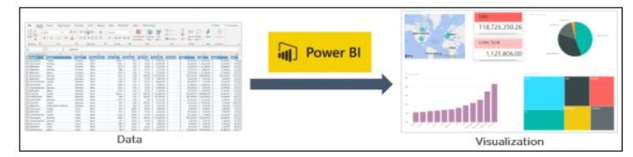

To deliver outstanding business intelligence solutions Microsoft Power BI technology consists of a group of components such as:-

1. Power Query - It is the data transformation and mash of the engine. It enables you to discover, connect, combine, and refine data sources to meet your analysis need.
2. Power Pivot - It is a data modeling technique that lets you create data models, establish a relationship and create calculations. It uses Data Analysis expression(DAX) language to model simple and complex data.
3. Power View - It let you create interactive charts, graphs, maps, and other visuals that bring your data to life. It can connect to data sources and filter data for each visualization element or the entire report.
4. Power Map – It is a 3D visualization tool that let you map your data and plot more than a million rows of data visually on Big maps in 3-D format.
5. Power BI Desktop – It is a development tool for Power Query, Power Pivot, and Power View. With Power Bi Desktop you have everything under the same solution, and it is easier to develop BI and Data Analysis Experience.
6. Power Q&A - It lets you explore your data in your own words. It is the fastest way to get an answer from your data using natural language.

Power BI Architecture is a service built on top of Azure. There are multiple data sources that Power Bi can connect to. Power BI Desktop allows you to connect reports and data visualizations on the dataset. Power BI Gateway is connected to on-premise data sources to get continuous data for reporting and analysis. Power BI services refer to the cloud services that are used to publish Power BI reports and Data Visualizations. Using Power BI mobile apps, you can stay connected to their data from anywhere.

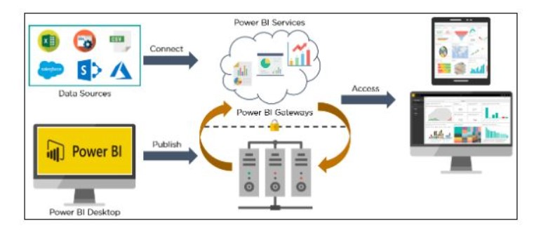

**2.2 Components of Power BI architecture.**

**1. Data Sources**

An important component of Power BI is its vast range of data sources. You can import data from files in your system, cloud-based online data sources, or connect directly to live connections. If you import from data on-premise or online services there is a limit of 1 GB. Some commonly used data sources in Power BI are :

* Excel
* Text/CSV
* XML
* Oracle Database
* IBM DB2 Database
* MySQLQl Database
* PostgreSQL Database
* Sybase Database
* Teradata Database
* SAP HANA Database
* SAP Business Warehouse Server
* Amazon RedShift
* Impala
* Google Big Query(Beta)
* Azure SQL Database
* Salesforcese Reports
* Google Analytics
* Facebook
* GitHub

**2. Power BI Desktop**

Power Bi Desktop is a client-side tool known as a companion development and authoring tool.

This desktop-based software is loaded with tools and functionalities to connect to data sources, transform data, data modeling, and create reports.

**3. Power BI Services**

Power BI Services is a web-based platform from where you can share reports made on the power bi desktop, collaborate with other users, and create a dashboard.

It is available in three versions:

* Free version
* Pro version
* Premium version

**4. Power BI Report Server**

The Power BI report server is similar to the Power BI Service. The only difference between these two is that Power BI Report Server is an on-premise platform. It is used by organizations who do not want to publish their report on the cloud and are concerned about the security of the data.

#### **5. Power BI Gateway**

This component is used to connect and access on-premise data in secured networks. Power BI Gateways are generally used in organizations where data is kept in security and watch. Gateways help to extract out such data through secure channels to Power BI platforms for analysis and reporting.

#### **6. Power BI Mobile**

Power BI Mobile is a native Power BI application that runs on iOS, Android, and Windows mobile devices. For viewing reports and dashboards, these applications are used.

#### **7. Power BI Embedded**

Power BI Embedded offers APIs which are used to embed visuals into custom applications.

**3. Deployment**

**3.1 Power Bi Deployment**

The deployment process lets you clone content from one stage in the pipeline to another, typically from deployment to test, and from test to production.

During deployment, Power Bi copies the content from the current stage, into the target one. The connection between the copied items is kept during the copy process. Power Bi also applies the configured deployment rules to the updated content in the target stage. Deployment content may take a while, depending on the number of items being deployed. During this time, you can navigate to the other page of the Power BI portal, but you cannot use the content in the target stage.

**3.2 Publish Dataset and report from Power Bi Desktop**

When you publish a Power BI desktop file to the Power BI service, you publish the data in the model of your Power Bi workspace. The same is true for any report you create in the Report View. You’ll see a new dataset with the same name, and any report in your Workspace navigator.

Publishing Power BI Desktop has the same effect as using Get Data in Power BI to connect and upload a Power BI Desktop file.

